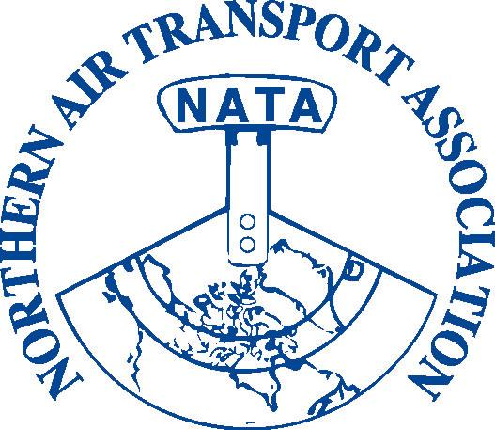
NATA 37th Annual Conference,
General Meeting & Trade Show

BOOTH REGISTRATION

Trade Show: April 8-10th, 2013
The Explorer Hotel, Yellowknife, NT

Space is Limited – Please Book Your Booth Early
Exhibitors registered by March 15, 2013 will be listed in the Program

Standard Booth Space includes:  one skirted 6’ table  two chairs  (7’ wide booth space with space for chairs behind the table) | Booth fee (please refer to page 2) based on one business per booth;  (Booth sharing must be pre-approved: email your request and details to NATA, extra charges will apply based on specific circumstances)

Please note that spaces are not curtained off. You are welcome to bring in your own trade show booth as long as it fits within the space provided. Booth fee includes full conference registration for one booth staff. Additional booth staff must pay for meals as indicated*.

Set-up hours: Monday, April 8th noon to 6:00 PM
Tear-down after 5:00 PM on Wednesday, April 10th

Trade Show Hours

April 9th 7:30 am – 5:30 pm
April 10th 7:30 am – 5:30 pm
Booths to be manned during breakfast, coffee and lunch breaks

Shipping:

Trade Show Booths and promotional material can be shipped in advance to:

The Explorer Hotel
4825 49th Avenue
Yellowknife, NT X1A 2R3
Please label packages “NATA Trade Show”
Phone: 867 873-3531
Fax: 867 873-2789

NATA TRADE SHOW BOOTH REGISTRATION

Company Name: | OFFICE USE ONLY  Member: _______  Inv #:___________  Posted: J________  Date: ________  Chq./Auth. #:  ___________  Receipt #: ______  Posted: J_______

Mailing Address:

Contact Person:

Phone:

Fax:

Email:
Booth staff:

Name of person staffing booth (and using registration included):

Position/Title:

Name of additional booth staff (*must pay $95 fee as indicated below):

Position/Title:

Booth registration fee | Cost | GST | with GST | Purchase Amount
Member Booth fee (includes one conference registration) | $ 850.00 | $ 42.50 | = $ 892.50
Non-member Booth fee (includes one conference registration) | $1,150.00 | $ 57.50 | = $1,207.50
Fee Sub-total A: |  |  |  | = $

Additional booth staff fee | Cost | GST | with GST | Purchased
Breakfast, Lunch & Breaks (April 9 & 10)* | $ 95.00 | $ 4.75 | = $ 99.75
President’s Reception (optional) | $ 30.00 | $ 1.50 | = $ 31.50
Annual Banquet (optional) | $ 100.00 | $ 5.00 | = $ 105.00
Fee Sub-total B: |  |  |  | = $
Fee Total (sub-total A + sub-total B) |  |  |  | = $
(GST 12166 4130 RT0001)
Payment method: □ Visa □ MasterCard □ American Express
Card Number:
Expiry Date: |  | Security Code: (back of card)
Card Holder Name:
Card Holder Signature: |  |  | Date:
□ Cheque □ Money Order (Payable to Northern Air Transport Association in CDN funds) □ Cash
Please check here if: an invoice is required □ a receipt is required □

Payment in full is due upon registration
Cancellations will be accepted up to March 15, 2013 for a full refund

Preferred Booth numbers (1-17): ____, ____, or ___
(please indicate top three choices - shown in the layout on page 3)

Special Requirements and Requests: (hotel has wireless internet)
□ Power Outlet □ Other__________________________________________
(rental fees may apply)
Please fax, email or mail Page 2 to:
Fax: 1-866-977-6282 or Email: admin@nata-yzf.ca or
Mail: Northern Air Transport Association P.O. Box 20102 Yellowknife, NT X1A 3X8

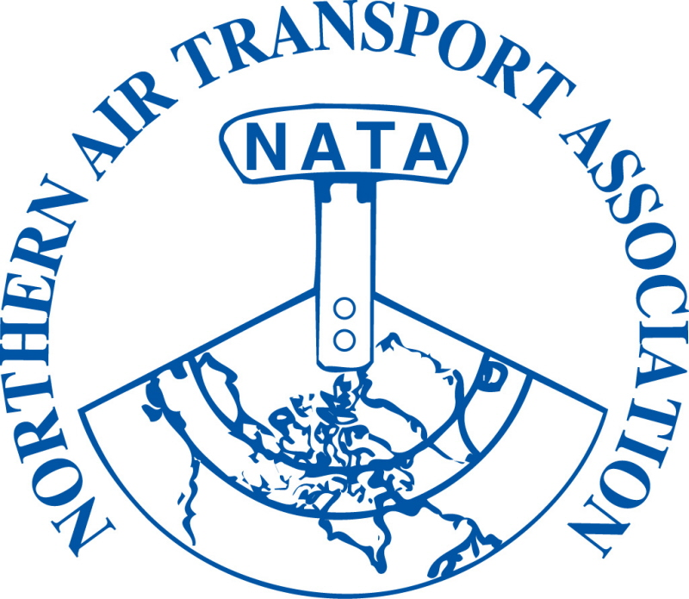

37th Annual Conference – Trade Show

Booth Layout

Please ensure you indicate your top three booth choices on the booth registration form (Page 2). See attached diagram (Page 4) for booth number/location.
Food will be served buffet style with delegates returning to the room to eat.

If you have any questions please don’t hesitate to contact:
Colin Dempsey, Executive Assistant at 867-446-6282 or admin@nata-yzf.ca

We look forward to seeing you in Yellowknife!

