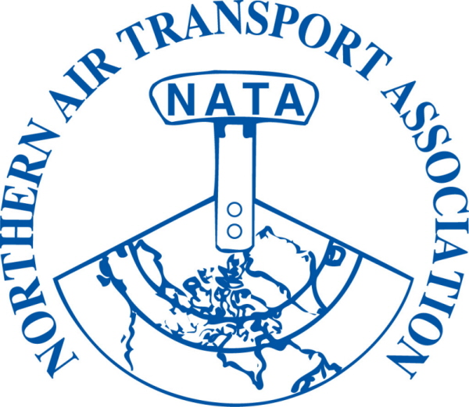 | NON-MEMBER REGISTRATION FORM  37th Annual Conference  Apr 8-10, 2013  The Explorer Hotel, Yellowknife, NT  For information about becoming a member visit our website www.nata-yzf.ca | FOR OFFICE USE ONLY  Inv #:_______________  Posted: J__________  Chq./Auth. : ___________  Receipt #: ________  Posted: J_______

DELEGATE NAME: |  | Title:
(to appear on name tag) |  | (to appear on name tag)
Company:
Mailing Address:
City: Province/Territory: Postal Code:
Phone: ( ) |  | Fax: ( )
Email:

Full delegate registration includes all meetings, functions and meals including:

President’s Reception, Annual Banquet and Bush Pilot’s Breakfast
Full Registration on or before March 15, 2013  $325.00 + $16.25 GST = $ 341.25 |  | Full Registration after March 15, 2013  $350.00 + $17.50 GST = $ 367.50
Sub-total B = | $ | Sub-total B = | $

***ADDITIONAL TICKETS FOR GUESTS NOT REGISTERED AS CONFERENCE DELEGATES***
Guest Names:
(please provide for guest lists)
 |  |  |  |  |  |  | # of Guests
Monday | President’s Reception | $ 35.00 | + $ 1.75 GST |  | = $36.75 | x |  | = $
Tuesday | Annual Banquet | $ 100.00 | + $ 5.00 GST |  | = $105.00 | x |  | = $
Wednesday | Bush Pilot’s Breakfast | $ 30.00 | + $ 1.50 GST |  | = $31.50 | x |  | = $
 |  |  |  | Sub-total C:
 |  |  |  | (1) Sub-total A or B:
 |  |  |  | (2) Sub-total C:
GST# 12166 4130 RT0001 |  |  |  | (1) + (2) + (3) = Total due: |  |  |  | $

□ Visa □ MasterCard □ American Express *Card Number: __
Exp Date: / Card Holder Name: __
Security Code: _ Signature of Card Holder: ______________________ Date: __
□ Cheque □ Money Order (Payable to Northern Air Transport Association in CDN funds) □ Cash
*credit card number is destroyed once transaction is completed

Email to: admin@nata-yzf.ca or
Fax to: 1-866-977-6282 or
Mail to: Northern Air Transport Association, P.O. Box 20102, Yellowknife, NT X1A 3X8

Questions?: Contact us at admin@nata-yzf.ca or 867.446.6282

