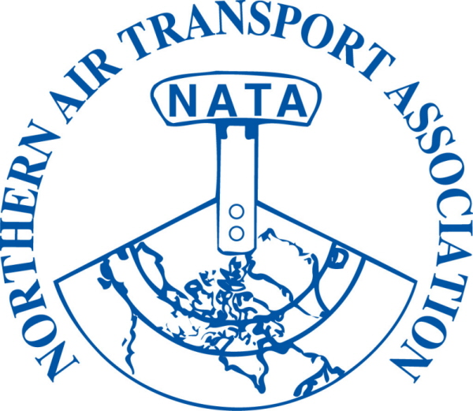 | MEMBER REGISTRATION FORM  35th Annual Conference  April 11, 12 & 13, 2011  Explorer Hotel, Yellowknife, NT  ~ Please Print/Type ~

DELEGATE NAME:
(to appear on name tag)
Title:
Company:
Mailing Address:
City: Province/Territory: Postal Code:
Phone: ( ) |  | Fax: ( )
Email:

Registration entitles delegates to all meetings, functions and meals indicated in Program
Full Registration By March 11, 2011  $210.00 + $10.50 GST = $ 220.50  Sub-total A = $ _____ | Full Registration After March 11, 2011  $250.00 + $12.50 GST = $ 262.50  Sub-total B = $ _____

ADDITIONAL (GUEST) FUNCTION TICKETS:
Guest Names: (if they would like a name tag)

 |  |  |  |  |  | No.
Monday | - President’s Reception | $ 25.00 | + $ 1.25 GST | = $26.25 | x |  | = $
Tuesday | - Annual Banquet | $ 75.00 | + $ 3.75 GST | = $78.75 | x |  | = $
Wednesday | - Bush Pilot’s Breakfast | $ 25.00 | + $ 1.25 GST | = $26.25 | x |  | = $
 |  |  |  | Sub-total C:
 |  |  |  | (1) Sub-total A or B:
 |  |  |  | (2) Sub-total C:
GST# 12166 4130 RT0001 |  |  |  | (1) + (2) = Total due: |  |  | $

□ Visa □ MasterCard □ American Express Card Number: __
Exp Date: / Card Holder Name: __
Security Code: _ Signature of Card Holder: ______________________ Date: _______________
□ Cheque □ Money Order (Payable to Northern Air Transport Association in CDN funds) □ Cash

Email to: admin@nata-yzf.ca or
Fax to: 1-866-977-6282 or
Mail to: Northern Air Transport Association, P.O. Box 20102, Yellowknife, NT X1A 3X8

Questions?: Contact us at admin@nata-yzf.ca or 867.446.6282

Participants Registered by March 11, 2011 will be included in the participants list in the Program

