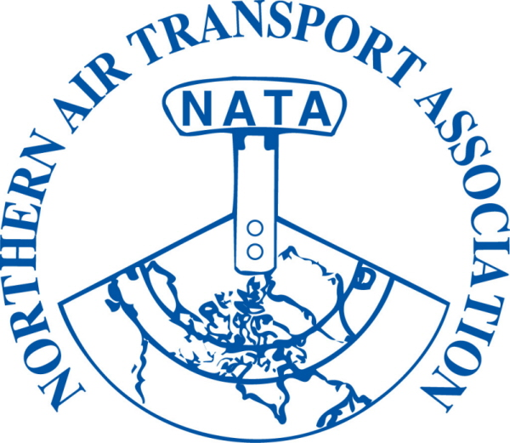

January 3, 2014

For more information regarding sponsorship please contact the members of the

Sponsorship Committee:

Trevor Bjorklund
Trevor.bjorklund@aon.ca
604.557.2584

Rick Pedersen
rpedersen@conair.ca
604.557.2584

Trevor Wever
twever@airtindi.com
867.872.2216

Wayne Woytkiw
Wayne.woytkiw@
eurocopter.ca
604.362.8614

2014 NATA AGM, Conference and Trade Show will take place at The Westmark Hotel in Whitehorse, YT from April 28-30th.

Interested in hosting a booth at our Trade Show? Please contact Colin Dempsey at:
admin@nata-yzf.ca for more information.

www.nata-yzf.ca

Re: 38th NATA AGM, Conference & Trade Show Sponsorship

Dear Sponsor,

We are writing to request your support in the form of sponsorship for the 38th NATA Annual Conference, AGM and Trade Show to be held April 28-30th, 2014 in Whitehorse, YT. Approximately 200 delegates from various sectors of the aviation industry will be in attendance as well as representatives from territorial and federal governments at this three-day event.

Thanks to the support of sponsors like yourself, NATA is able to host an informative conference with guest speakers, panel discussions and social events that provide delegates with opportunities to network and to keep up-to-date on issues affecting aviation in Northern Canada.

Please find attached a Sponsorship Form for the 2014 NATA Annual Conference, AGM & Trade Show. Please email, fax or mail this form back early to ensure your company its choice of item for sponsorship.

Once sponsorship commitments are received, sponsor logos will be included on the NATA website, future Annual Conference correspondence, the event Program, and in the sponsor recognition slideshow that will run during breaks. Sponsors that submit their Sponsorship Form by March 15, 2014 will have their logo included in the event Program.

Thank you and we look forward to hearing from you.

Sincerely,

Andrew Bailes
President - NATA

attachment

SPONSORSHIP FORM
2014 AGM, CONFERENCE &
TRADE SHOW

Please complete form and return by E-mail, Fax or Mail

- PLEASE PRINT CLEARLY-
Company Name

Contact Name
Address
City, Prov./Terr. |  |  | Postal Code:
Phone Number |  | Fax:
Email Address

We would like to sponsor the 38th NATA AGM, Conference and Trade Show with a

contribution of $_____________ towards:
(please indicate 3 items by numbering in order of preference)

 | President’s Reception |  | April 29th Continental Breakfast

 | April 29th AM Coffee Break |  | April 29th Lunch

 | April 29th PM Coffee Break |  | Annual Banquet Reception

 | Annual Banquet Meal |  | Annual Banquet Wine for Meal

 | Annual Banquet Table Centre-pieces |  | April 30th Bush Pilots Breakfast

 | April 30th AM Coffee Break |  | April 30th Lunch

 | April 30th PM Coffee Break |  | Delegate Name Tags

Thank you for your support

For your convenience sponsorship funds can be provided by cheque (CDN funds please) or credit card. Please make cheques payable to:

Northern Air Transport Association

If paying by credit card please use the attached credit card payment form

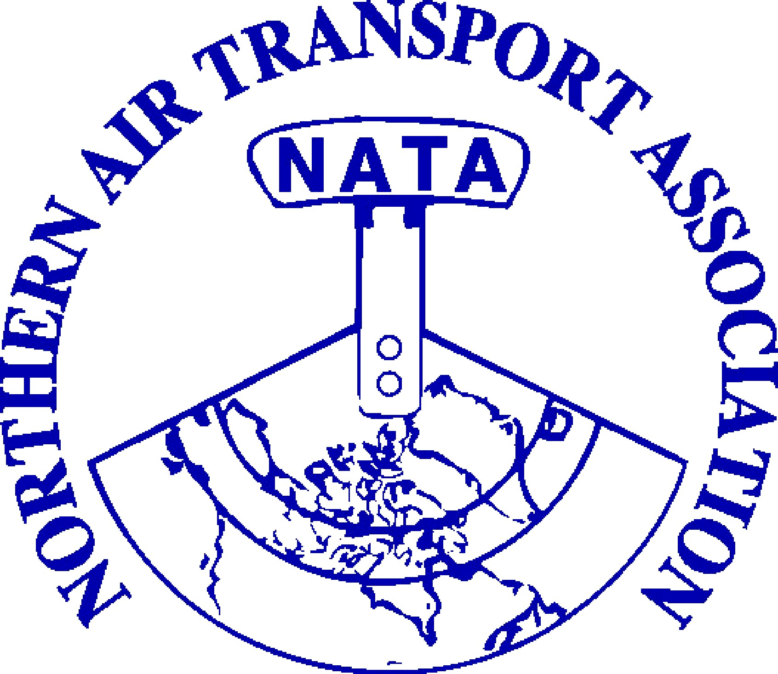  CREDIT CARD  PAYMENT FORM | FOR OFFICE USE ONLY  Invoice #:______________  Posted: J________  Date: ___________  Chq./Auth. #: __________  Last 4 digits of CC: _______  Receipt #: ________  Posted: J_______

PLEASE TYPE or PRINT CLEARLY

Invoice Number:
(if known)

Balance Due:

Payment Amount:

Card Type: | Visa: |  |  | MasterCard: |  |  | Amex:

Name on Card:

Card Billing
Address:

Card Holder Signature:

Credit Card #:

Expiry Date: |  |  |  | Security Code:
 |  |  |  | (from back of card)

~ credit card number information will be destroyed once transaction is completed ~

