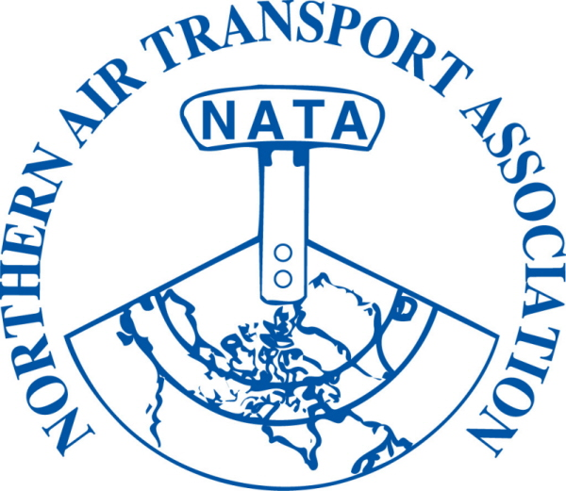 | MEMBER REGISTRATION FORM  38th Annual Conference  Apr 28-30, 2014  The Westmark Hotel, Whitehorse, YT

DELEGATE NAME: | Title:
(to appear on name tag) | (to appear on name tag)
Company:
Mailing Address:
City: Province/Territory: Postal Code:
Phone: ( ) | Fax: ( )
Email:

Full delegate registration includes all meetings, functions and meals.
Full Registration on or before March 14, 2014  $255.00 + $12.75 GST = $ 267.75 | Full Registration after March 14, 2014  $300.00 + $15.00 GST = $ 315.00

Sub-total A = | $ | Sub-total B = | $

***ADDITIONAL TICKETS FOR GUESTS NOT REGISTERED AS CONFERENCE DELEGATES***

Discounted rate for the 3rd and subsequent registrations from a single member organization
$245.00 + 12.25 GST = | $ 257.25 | Sub-total C = | $
Guest Names: (please provide for guest lists)

Monday | - President’s Reception | $ 35.00 | + $ 1.75 GST | = $36.75 | x |  | = $
Tuesday | - Annual Banquet | $ 75.00 | + $ 3.75 GST | = $78.75 | x |  | = $
Wednesday | - Bush Pilot’s Breakfast | $ 30.00 | + $ 1.50 GST | = $31.50 | x |  | = $
 |  |  |  | Sub-total D: |  |  | $

 | (1) Sub-total A or B:
 | (2) Sub-total C:
GST# 12166 4130 RT0001 | (3) Sub-total D:
GST# 12166 4130 RT0001 | (1)+(2)+(3)+(4) = Total due: | $

□ Visa □ MasterCard □ American Express Card Number: __
Exp Date: / Card Holder Name: __
Security Code: _ Signature of Card Holder: ______________________ Date: _______________
□ Cheque □ Money Order (Payable to Northern Air Transport Association in CDN funds) □ Cash

Email to: admin@nata-yzf.ca or
Fax to: 1-866-977-6282 or
Mail to: Northern Air Transport Association, P.O. Box 20102, Yellowknife, NT X1A 3X8

Questions?: Contact us at admin@nata-yzf.ca or 867.446.6282

