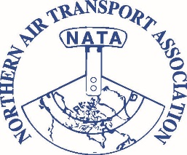 |  | Northern Air Transport Association  Special Board of Directors Virtual Meeting  November 27, 2020  AGENDA
NATA Board |  | Wendy Tayler, Alkan Air-President  Brian Crocker, Ken Borek Air- First Vice President  Aaron Speer- Canadian North 2nd Vice President  Myles Cane, Summit Air- Secretary/Treasurer  Trevor Wever, Air Tindi- Past President  Board Members  Joe Sparling, Air North; Wayne McLeod, Keewatin Air; Vince Crooks, Wilderness Seaplanes; Travis Wright, North Wright Air; Sebastien Michel, Air Inuit; Jonathan Talon, GSL; Mark Gallant, Conair; Todd Kempthorne, Marsh LLC; Steven Williams, Emond Harnden; David MacPhail, ATS  Colin Dempsey NATA GM; Glenn Priestley Executive Director
Regrets-
Invited Guests: |  | Warren Everson- NATA Members
1 | Welcome Round Table- Directors new issues for agenda
2 | Approval of Agenda
3 | Approval of the last BOD decision record
4 | New Business Arising from Minutes of last meeting
5 | Secretary – Treasurer’s Report
6 | President’s Report
7 | Executive Director report – See attached Excell Activity Report
8 | NATA Member Call In- Opportunity for members to call in and discuss concerns with Board members, as well as offer next steps for NATA
9 | Guest Presentation- Warren Everson Ottawa Update-
10 | All Member Invite: Around the Table- Time and Location of Next Meeting /Adjournment of Meeting

